PVT Manual

Performance Validation Test

To test truck related products from an end user functional perspective

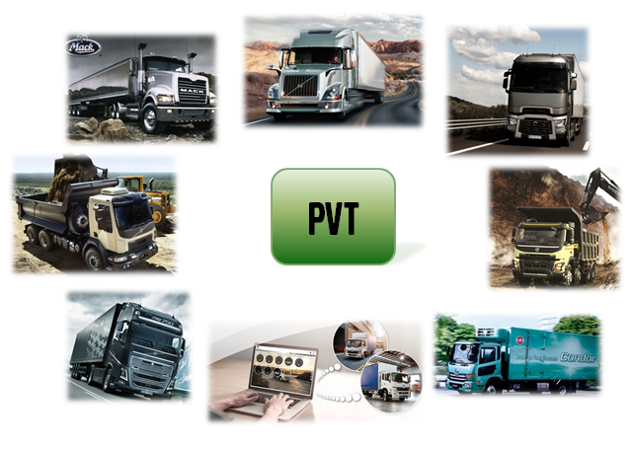

Purpose with this document:

* To present and explain the PVT test methodology and culture
* Be a guideline for new personnel involved in PVT
* Be a reference for all personnel involved in PVT
* Be a source of information for customers and other stakeholders
* To secure that a PVT is performed in a harmonized way
* The first chapter should give a sense of PVT, the next chapters includes more details

This document is under constant update and any printed copy may be out of date.

Any feedback on this document is most welcome, please send it to:

Jessica Erlandsson [jessica.erlandsson@volvo.com](mailto:jessica.erlandsson@volvo.com)

Tim Jansson [tim.jansson@volvo.com](mailto:tim.jansson@volvo.com)

Contents

1. Revision History 3

2. What is PVT? 4

2.1. PVT – Performance Validation Test 4

2.2. Global presence 5

2.3. PVT Mission 5

2.4. PVT Expected outcome 5

2.5. PVT Stakeholders 7

3. Performance Validation Tests 8

3.1. Purpose 8

3.2. Why Truck Functions? 8

3.3. Test structure 9

3.4. Test Descriptions 10

3.4.1. PVT Check 10

3.4.2. PVT Base 10

3.4.3. PVT Total 10

3.4.4. PVT Europe (US/SA/Japan/India) 11

3.4.5. PVT Development 11

3.4.6. Test differences: Example 1 – Cruise Control 12

3.4.7. Test differences: Example 2 – Cab Heater 13

3.5. How tests are connected to project phases 14

4. PROTUS 15

4.1. PVT Global way of working 15

4.1.1. PVT failure investigation 15

4.1.2. Discussion with concerned team (optional) 16

4.1.3. Cross functional decision meeting (status 35) 16

4.1.4. Solution verification 16

4.1.5. Report set to status 7 16

4.1.6. PROTUS closure (status 8) 16

4.2. PVT Protus guidelines 16

5. PVT Tools 17

5.1. E-FACTS 17

5.2. Collector 17

5.3. Refiner 17

5.4. PVT Manager 17

5.5. Log equipment 17

5.6. Tools during testing 17

6. Process 18

6.1. PVT Process documents 18

6.2. VGMS – Volvo Group Management System 18

6.3. Former V&V-plan process 19

6.4. PVT Roles 20

6.4.1. PVT Driver Competence 21

# Revision History

|  |  |  |  |
| --- | --- | --- | --- |
| **Release** | **Date** | **Comment** | **Author** |
| 0.1 | 2013-03-06 | Document created | Johan Adoson |
| 0.2 | 2013-04-08 | First review. Not yet developed areas marked with yellow | Johan Adoson |
| 1.0 | 2013-04-25 | After first review. Updates of structure, spelling, order of word and grammar. | Johan Adoson |
| 1.1 | 2014-05-14 | New and updated information marked with color.  Section “Result” detailed  Check, Base and Total further detailed  Metamodel added | Johan Adoson |
| 1.2 | 2014-05-15 | Updated Generic Startup meeting agenda | Johan Adoson |
| 1.3 | 2015-08-21 | Name changed from PVT Handbook to PVT Manual. Updated with new FVV organization, TFV removed and replaced with PVT Global Team  Updated chapters 1,2,3. | Tim Jansson/ Jessica Erlandsson |
| 1.4 | 2016-06-14 | Updated all chapters | Tim Jansson/Jessica Erlandsson |
| 1.5 | 2016-08-30 | PVT Global Team review | Tim Jansson/Jessica Erlandsson |
| 1.6 | 2016-11-17 | Review comments updated and marked in Green | Tim Jansson/Jessica Erlandsson |
| 2.0 | 2016-12-05 | Green marked text turned into normal text.  PVT Internal Process descriptions added to chapter 6.1 (new chapter).  Small changes in chapter 6.2.(chapter 6.1 in version 1.6) according to “PVT Manual Backlog.xls”.  . | Tim Jansson/Jessica Erlandsson |
|  |  |  |  |

# What is PVT?

PVT is a manual customer-oriented functional test method with different levels of testing based on test cases and exploratory testing. It is performed by experienced users and the issues found shall always be logged to support the root cause analysis.

One main objective is to present the status of a product and shall include both positive and negative feedback.

## PVT – Performance Validation Test

PVT test the truck functions and the truck related products from a user perspective. The level of test depth is similar to the driver manual and the testing includes both verification[1] and validation[2]. It is performed both structured with test cases and as exploratory testing where the tester is free to use the products as an end user would do. The testers are experienced drivers or users.

Verification: -***“Are we building the product right?”*** (I.e. as specified)

Validation: ***-“Are we building the right product?”*** (I.e. are the specifications right?)

PVT should be performed in as close environment as possible to how the end user would use the products. Normally a PVT is performed in a truck on public roads; in different traffic environments, climates and road conditions.

In early phases, PVT can be performed in rigs or simulated environments to get driver perspective into the projects as soon as possible (long before there are solutions in the real trucks). PVT can also be performed, when necessary, on Proving Grounds where events, different slope levels and road conditions can simulate real situations.

During a PVT it shall always be possible to record a log of information if something happens that shall be reported in order to support root cause analysis. For trucks, an ideal log would be to capture all vehicle data communication. The M-Logger is the current logging tool for PVT testing.

Examples

1. PVT compared to rig testing

PVT is a manual test method using products in the targeted environment. The testers shall have experience from using the products externally in different applications in order to be able to represent the customers. This experience enables exploratory testing and the possibility to test the products beyond the requirements.

Rig testing can be both manual and automated and is an efficient method to verify requirements. The rigs can be isolated subsystems and box trucks and the tests are often limited to commodity responsibility, meanwhile PVT covers the complete product.

1. PVT compared to feature testing

Features and functions have a many-to-many relationship. Feature testing secures that the feature requirements are fulfilled which often are dependent on several functions. The functions in feature testing are tested from one feature perspective, for example braking, handling and driver interface.

PVT tests functions from a holistic usage of the products.

For example, the driver interface feature leader verifies that a button has certain size and feeling, while PVT validates the button while using a function in customer scenarios.

Feature testing and PVT testing are complementary methods to ensure the products will meet the customers’ requirements.

## Global presence

PVT is currently performed on products within the Volvo Group on six different sites: AGO, BLR, CUR, GOT, GSO and LYS.

## PVT Mission

The PVT mission is to

1. Find and report product quality related issues before external customers find them.
2. Provide data to support root cause analysis of the issues.
3. Validate if the products are usable and fulfill the end customer expectations

E.g. raise and report subjective issues that in the customer´s point of view could bring disappointment and annoyance, highlighting issues that can affect the quality impression for Volvo Group brands.

1. Present results from testing the truck functions from an end user perspective.
2. Provide end user input during all project cycles or in maintenance phases.

E.g. in early phases or before projects have been initiated the input can be in the format of competitor benchmarks, clinics/mock-up tests, simulations, data from a test with prototypes or as simple as discussions using experience from external usage or previous test results.

## PVT Expected outcome

1. Truck Function Status from different PVT Tests reflecting the product status, not exclusively project status. The reason behind it is that we sell products to our customers and not projects.

* Protus reports or other ways of reporting issues - Most important delivery
  + Verification (L-reports)
  + Validation (P-reports)
* Test case follow-up – OK/NOK/Blocked/Not Tested/Not Applicable
* Highlight the customer holistic view on the products – minor faults combined might cause big problems for the customers or impact brand image.
* ER – Engineering Report

1. Project status

* An overview of the current status of the Truck Functions within a project. It can be presented as the “Italian flag”, PVT SW Release Comparison
  + Green, Improved = What is better than last test
  + White, Not Improved = What is status quo since last test
  + Red, Declined = What is worse than last test/severe issues that needs to be highlighted

|  |  |  |
| --- | --- | --- |
| Improved | Not improved | Declined / Severe issues |

Fig. 1 - Italian Flag status reporting

* Project status meetings including PPL and other stakeholders

1. Project support/Frontloading

* Friday functionality – how does the function work in the current products
* End user knowledge/how the products are used in reality
* Complete Vehicle Knowledge
* Truck ride along
* In-truck meeting – hard to explain everything in text
* Suggestions on improvements
* Competitor Benchmarks
* Market specific demands from a driver perspective
* Experience from other projects
* Concept/Technology Readiness Level evaluations (clinics, simulations, discussions etc)
* Comparison between concepts in order to deliver data and opinions that can be used as main basis for final concept selection.
* Functional Walkthroughs (where project changes are described, Monday functionality)
* Stakeholder in early functional development phases (stakeholder in Technical Report reviews etc.)

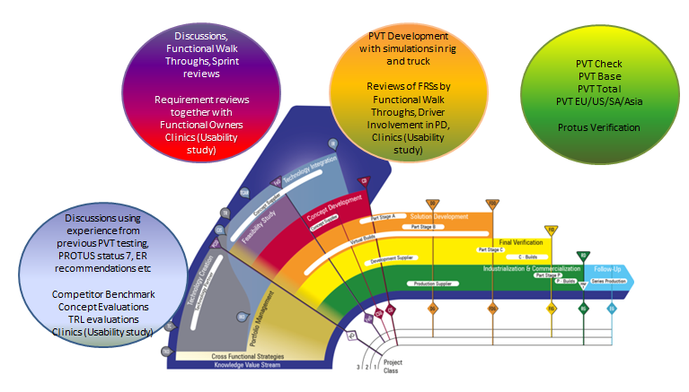

Fig. 2 - PVT Input throughout the Development Process

## PVT Stakeholders

* Project Managers – FVVPM plans the PVT test in the project V&V plan

(Verification & Validation plan) and secures the budget

* Feature owners
* Function owners
* Developers
* Next test owner
* PPL
* Brand representatives
* Management

# Performance Validation Tests

## Purpose

The purpose with PVT is to find issues in the Volvo Group products before an external customer does. The mindset needs to correspond to several very demanding drivers and users in the intended market. The testing should cover as many different user scenarios as possible within normal usage of the product.

PVT is performed in a structured way with test cases for all truck functions and exploratory testing. Exploratory testing during PVT is when the PVT Driver/Tester or Test Engineer uses truck functions from a user perspective according to the PVT mindset without test cases.

The combination between structured and exploratory testing is what makes the difference with PVT, both are important to carry out. It is also important to strive toward testing as many variant combinations as possible, but try to prioritize the most common product offers.

To be able to spread information about issues that have been seen/found/experienced during the tests, PVT relies on capturing the needed truck or product data to make it possible to understand the issue and if necessary, solve the root cause.

The data can be CAN/LIN traffic combined with audio, pictures and video or other formats depending on the project needs.

Using the correct logging system is vital to PVT and this need to be hand shaken with the project. Providing correct data reduces lead time and increases efficiency for the Volvo Group.

## Why Truck Functions?

The Truck Function List contains all relevant functions in the product offer. It was developed during P2540 (FH 4) to reflect the complete product from a user perspective. The functions are divided into Truck Function Areas to easily find the right function.

Several lists of functions are used in GTT and the End-2-End function list is the most frequently used. The truck functions are mapped to one or several End-2-End functions which is documented in the Truck Function List.

An initiative to create one, unified end-user function list has started.

## Test structure

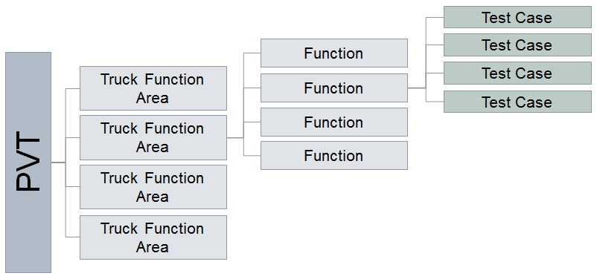

Fig. 3 Test cases in relation to Truck Functions

The test system structure is kept in a database environment and the structure supports traceability, analyses and evaluation of the data. The PVT Truck Function Specialist is responsible for the structure including the Truck Function List.

The structured part of PVT – test cases – shall always continue to evolve and change according to product updates. Each site has a designated Site Editor for test case development. This role together with the PVT Master Editor, are handling all test cases, requesting new, updating old, sending for review, stating what product class and/or variant the different test cases should be sorted on.

## Test Descriptions

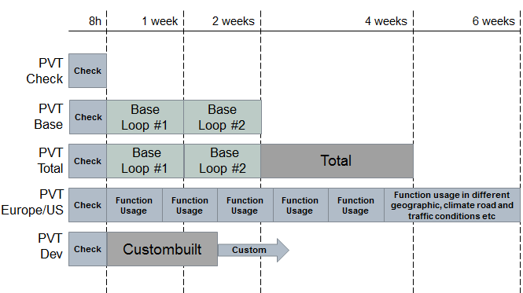

Fig. 4 Test Descriptions

### PVT Check

Status check of the vehicle, testing all truck functions available on the truck with a generic test code.

A PVT Check should be performed before starting all tests in order to secure status of all available truck functions.

### PVT Base

Normal usage of all available truck functions. Test sequence is run twice with different drivers. Exploratory testing should be 25-50% of the time.

### PVT Total

* A PVT Total covers the normal driving scenarios (PVT Base) and more advanced user scenarios.
* Overnight sleep in cab, 1-2 nights during a small expedition on public roads should be included.
* Some fault injections and some failure mode testing.
* Exploratory testing 25-50% of the time.

### PVT Europe (US/SA/Japan/India)

PVT Europe is a validation test driven on public roads in as many geographical conditions as possible.

Two drivers and 2-4 in cab sleep overs a week (2 nights per driver), parked where other external trucks are parked overnight.

A checklist of all available functions in the truck is needed for the exploratory testing – to secure all functions get tested.

Geographical conditions: Hilly, flat, close to sea, in mountains, hot climate, cold climate,

Different road and traffic scenarios – highway, country road, in city, dense traffic, slow traffic, traffic jams, light traffic, good roads, bad roads, toll roads, mountain roads.

No specific route is predefined; the route is to be decided dependent on the test content.

PVT Europe examples:

* Great Britain for left hand driving, narrow roads, ferry transport, train transport
* The Netherlands and Belgium for complex road networks, dense traffic (close to the sea)
* The Alps for mountains, tunnels, GPS signals, serpentine roads, temperature alterations
* Germany for highway and hilly conditions
* The Italian north west coast line – bad roads, a lot of tunnels
* Spain for long hills, hot climate
* Finland for cold climate
* All countries for different road toll systems, road signs, road markings, traffic behavior, Volvo on Call languages, radio reception…

This test should be developed for all markets where needed.

### PVT Development

PVT Development is a tailor made test code or exploratory test depending on the project. It can be performed in all project phases, best suited in the mid phases, before stable C-release.

When finished, the PVT test cases connected to the area should be reviewed and new shall be created to be able to test the contents in other tests in the future.

### Test differences: Example 1 – Cruise Control

|  |  |  |  |
| --- | --- | --- | --- |
| **Test name** | **Example** | **Scope** | **Possible results** |
| PVT Check | Cruise Control – activate and change set speed, check indications in cluster.  . | Perform once. The tester chooses how it should be tested. | Not possible to enable CC. |
| PVT Base | Cruise Control – test deactivation conditions, test over speed in downhill. | Use CC frequently during driving. Several drivers use the function. Exploratory testing covers more than test code. | CC over speed – retardation starts too late => cannot keep over speed limit |
| PVT Total | Cruise Control – use different eco levels and check over- and underspeed settings. | PVT Base + more time consuming test cases. | CC ecolevel – higher overspeed than set value. Too late VEB activation. |
| PVT Europe | All functions of the cruise control is used frequently on public roads | Cruise control is used every day in different scenarios | Intermittent faults and validation issues |
| PVT Development | Focus on the Cruise Control function and its surrounding system in complete vehicle driving scenarios. | Decided together with the project or requester. | Depends on maturity of the functionality and length of the test etc |

### Test differences: Example 2 – Cab Heater

|  |  |  |  |
| --- | --- | --- | --- |
| **Test name** | **Example** | **Scope** | **Possible results** |
| PVT Check | Cab Heater – test cab heater | Perform once. The tester chooses how it should be tested. | Cab Heater not possible to enable |
| PVT Base | Cab Heater – test cab heater timer. | The function is used several times by at least two drivers | Cab Heater is noisy or set value is not reached. |
| PVT Total | Cab Heater – test that cab heater stops after 10 hours. Use Cab Heater during overnight sleep. | PVT Base + more time consuming test cases. | Intermittent faults, e.g. when using parking heater during overnight sleep, it stops to work after 4 hours. |
| PVT Europe | Cab Heater | Used many times during days and nights, when driving, resting and living in the cab | Intermittent and validation results. |
| PVT Development | Focus on the Cab Heater function and its surrounding system in complete vehicle driving scenarios. | Decided together with the project or requester. | Depends on maturity of the functionality and length of the test etc. |

## How tests are connected to project phases

PVT can be performed in all project phases, but in different ways. The test focus should start with project content in early phases and transfer into product focused testing in late phases.

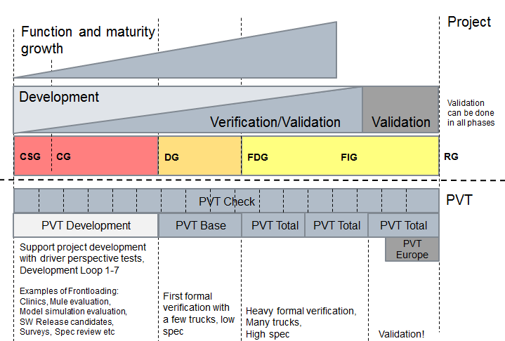

Fig. 5 How tests are connected to project phases

# PROTUS

## PVT Global way of working

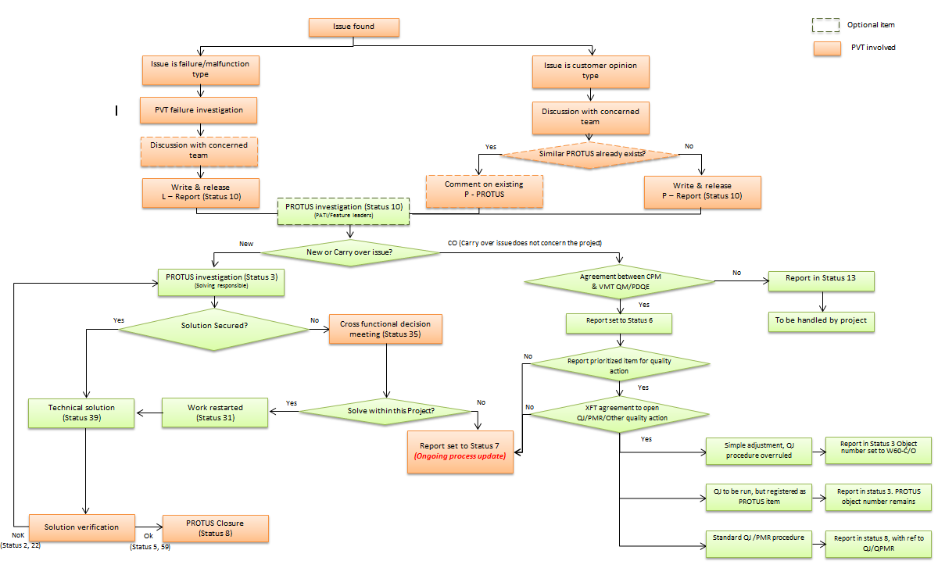

Fig. 6 - PVT Global way of working with PROTUS

During Spring 2016 the global PVT Team developed this common process for PROTUS, the steps where PVT is involved are described more detailed in chapter 4.1.1- 4.1.6.



### PVT failure investigation

First an investigation is done to be able to write the report with as much information as possible in order to ease the root cause analysis and thereby cut lead times (but it is not PVT main task to perform deep trouble shooting).

Strive to always include a logfile in a protus report from PVT. Use PVT Protus guideline, chapter 4.2, to make good reports. Always add vehicle ID, test and SW in header of report. FH-1900, PVT, “Header text”. SW P04. This also improves the possibilities for searches.



Fig. 7 Example of PROTUS report title

### Discussion with concerned team (optional)

Before issuing a report, try to talk to the receiver to have a good hand over. This is not always possible since there might be too many reports to write from a PVT test and that is the reason to make the discussion optional.

### Cross functional decision meeting (status 35)

Be part of the status 35 meeting to tell why the issue has been reported and how it might cause problems to our external customers.

### Solution verification

When issues have been corrected they shall be retested in the same environment as they were found. Try to retest on a similar truck specification.

### Report set to status 7

Aims towards issues out of scope for the project but good to know about the product and solve in future projects.

### PROTUS closure (status 8)

If you do not agree to close the report, write a technical comment or try to move the issue to status 7.

The status 8 might change to be divided into different reasons to closure.

## PVT Protus guidelines

* If a project has many SW releases with PVT tests, the same faults need to be reported in every SW release and in every vehicle
  + To make it visible
  + To get the correct statistics and holistic view of the releases
  + To be able to compare releases
  + One symptom might have different root causes
* Find trade-off between Testing, Reporting and Meeting the project
  + Testing and reporting should be prioritized as much as possible
  + Efficient to meet the receivers when discussions start
* Protus verification – shall be conducted on officially released software
* A project orders a PVT test but always report all product issues that are found
  + Help the project to handshake/set the reports to other projects or status 7.

# PVT Tools

The below tools are used to support PVT Testing during the planning, execution and closure phase. This also include to delivery recorded data to Engineering for PROTUS solving.

## E-FACTS

The E-FACTS applications enable to handle upload of data from the logger in a structure way and the possibility to analyze the audio/video recordings to create a link to the recorded data into PROTUS.

## Collector

The Collector is used to connect the logger serial number to the truck, where the logger is installed. It also have metadata about installation date, product class, chassis id, test type, test leader, test site and SW release version. Data from the logger is uploaded to the server using the Collector application.

## Refiner

Refiner is used to analyze the uploaded data, by listening to audio/video, writing info/adding metadata about the fault found and adding the PROTUS-id. The user can also discard recorded events. After the test, the Truck Function Status is reported in this tool.

## PVT Manager

PVT Manager is mainly used to handle the test cases, truck functions and test sequences used during testing. It handles the test case jobs that are sent between the test leader, site editor and master editor. It is also used during planning to check how which truck functions will not be tested based specification for the trucks selected in the test. It also creates reports based on the result from the test.

## Log equipment

Different log tools can be used during PVT Testing, but the main logger is MLOG with accessories. The setup in the MLOG can be customized for local demands.

## Tools during testing

PROTUS

PROTOM

Engineering Tool

CANalyzer

Vision

Tech Tool (design access)

# Process

## PVT Process documents

The PVT process has been documented with several documents.

1. PVT Test Request Process



1. PVT Test Process



1. PVT Protus Verification Process



1. PVT Test Case Process



1. PVT Job Handler Flow



## VGMS – Volvo Group Management System

In Volvo Group Management System, VGMS, PVT is located in the DVP – Develop Product & Aftermarket Product Portfolio. For the coming releases of the PVT Manual, PVT needs to be added with correct documents in the correct phases of development. The following power-point describes the intentions.



[Link to VGMS](http://vgms.vservices.net/pages/c488c54e5257107a.htm)

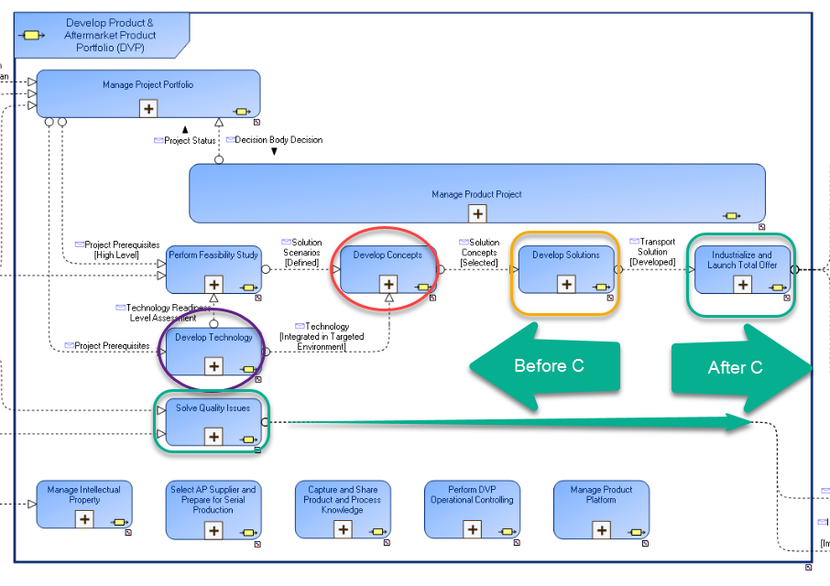

Fig. 8 - VGMS DVP process

## Former V&V-plan process

Whenever a new project is started and a new V&V (Verification&Validation) plan shall be developed, the PVT Manager (can be the local group manager or PVT site responsible or similar depending on the local PVT roles) shall be contacted to support with finding the relevant test plan for the specific project content. All PVT project test plans shall be tailor made dependent on the scope and product impact.

The old process (visualized in GTTMS) for how to update the V&V-plan (Verification and Validation Plan) seems to be missing in VGMS, but this picture might be helpful if there are any discussions on how to be involved early in projects.

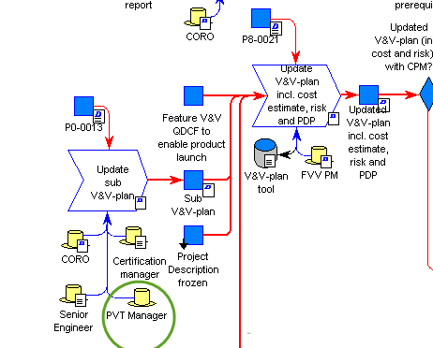

Fig. 9 - Former process for updating a V&V-plan

## PVT Roles

The following roles are present within the PVT Global Team, every role is responsible to give input to the PVT process, methods and tools.

|  |  |  |  |
| --- | --- | --- | --- |
| **Role** | **Type** | **Primary objective** | **Comment** |
| Global PVT Manager | Global | Overall responsible for global PVT process, methods and tools. | Leads global weekly meeting |
| Truck Function Specialist | Global | Responsible of the Truck Function List and the technical content of PVT Processes, Methods & Tools. | Participates in global weekly meetings |
| PVT Applications and Tools Responsible | Global | Develop and maintain applications and tools for PVT | Participates in global weekly meetings |
| PVT Developer | Global | Responsible for the global test cases to be aligned, accurate and on the right level. | Participates in global weekly meetings |
| PVT Telematics and Soft Offer Responsible | Global | Responsible for the telematics and soft offer parts of PVT. | Participate in global weekly meetings |
| Local PVT Responsible | Local | Local/site responsible for PVT. | Participates in global weekly meeting |
| PVT Test Engineer | Local | Lead a PVT in a truck or support projects with user perspective | Optional participation in global weekly meetings |
| PVT Driver | Local | Perform a PVT in a truck or support projects with driver input | Optional participation in global weekly meetings |
| PVT Tester | Local | Support PVT testing with truck knowledge expertise from both driver and mechanic perspective | Optional participation in global weekly meetings |
| Local Test Case Editor | Local | Responsible for the local used test cases. Report the needs to PVT Developer. | Optional participation in global weekly meetings |
| PVT Applications and Tools Local Superuser | Local | Responsible for the local applications and tools. Report the needs to PVT Applications and Tools Responsible. | Optional participation in global weekly meetings |
|  |  |  |  |
| **Optional** |  |  |  |
| PVT Planner | Local | Plan all PVT, Coordinate tests and resources |  |
| PVT Troubleshooter | Local | Troubleshoot issues and support PVT Engineers | Can be supported by commodities instead of be part of the team |

### PVT Driver Competence

PVT Drivers are vital to have good results from PVT testing. An experienced driver should easily understand the purpose of the function when reading the Truck Function name. This requires time to learn.

What is important?

* Curiosity
* External trucking experience
* Willingness to learn and contribute to development of test method, tools and way of working.
* Service orientated
* Team spirit
* Eagerness to share findings (give presentations and demos if necessary)
* Push for issues that impact customer image and product quality
* To be able to perform exploratory testing and constantly test the truck in new different combinations/scenarios.
* Sense for details (see, hear, experience)

1. Verification: The evaluation of whether or not a product, service, or system complies with a regulation, requirement, specification, or imposed condition. It is often an internal process. Contrast with *validation. Source: Wikipedia*
2. Validation: The assurance that a product, service, or system meets the needs of the customer and other identified stakeholders. It often involves acceptance and suitability with external customers. Contrast with *verification. Source: Wikipedia*